## Distributed Builds

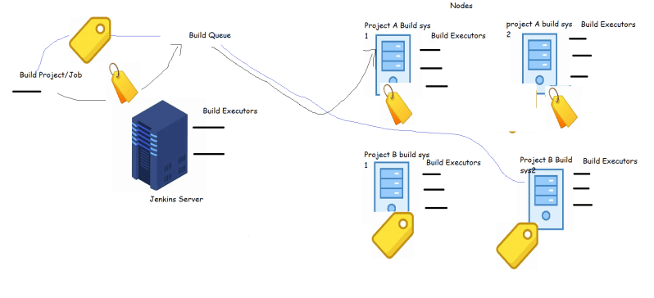

**Jenkins Distributed Builds**

* When we try to build a jenkins job, jenkins will try to find an executor. Jenkins server has by default 2 executor. This implies we can build two jobs in parallel.
* In an enterprise scenario, each project has its set of tools/softwares which might be different, to support this jenkins has node concept
* A node is a VM or Physical or docker container with preconfigured set of tools installed.
* We need to configure the connection b/w jenkins Server and node and also configure number of executors. Each node will/should have a label.
* Now once this configuration is done, then we can have our jobs build on different node than jenkins server
* This gives an option to have various builds configured from one highly available jenkins.
* Adding nodes to jenkins server gives us the flexibility to create various environments (QA,Dev, Staging, pre-prod)

**How to configure a node to Jenkins server**

* Jenkins tries to login into remote node and execute the job for this jenkins uses an agent from jenkins called as jenkins-agent
* On the jenkins node java 8 or java 11 has to be installed
* For our lab set up lets create a ubuntu 18 node install java and maven

sudo apt update

sudo apt install openjdk-8-jdk -y

sudo apt install maven -y

* To configure a linux node we need to configure the ssh communication between jenkins server and node
  + Jenkins server needs to know the username and password of the node
* Ensure password authentication is enabled by checking PasswordAuthentication value in /etc/ssh/sshd_config
* Ensure a user is created for running builds on jenkins node

sudo adduser jenkins

* Give the user necessary permissions
* Try to login into jenkins node from jenkins server as jenkins user
* Now lets try to configure this node from jenkins ui 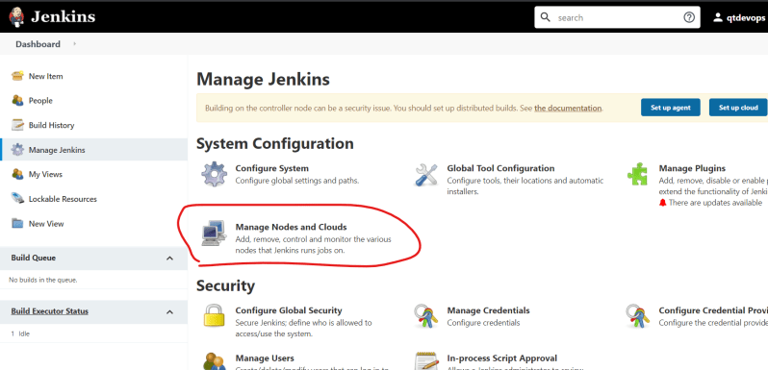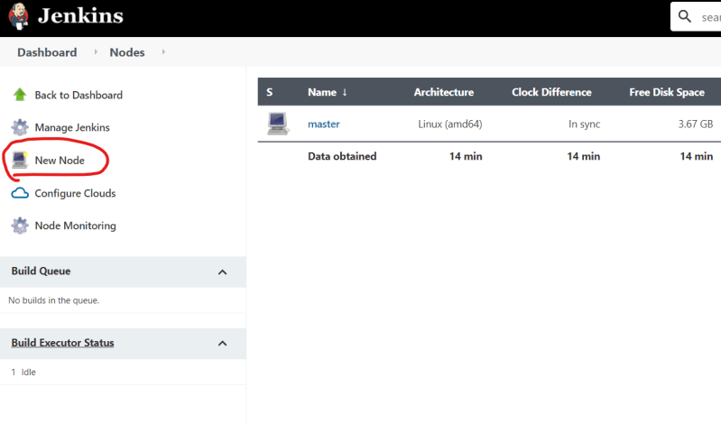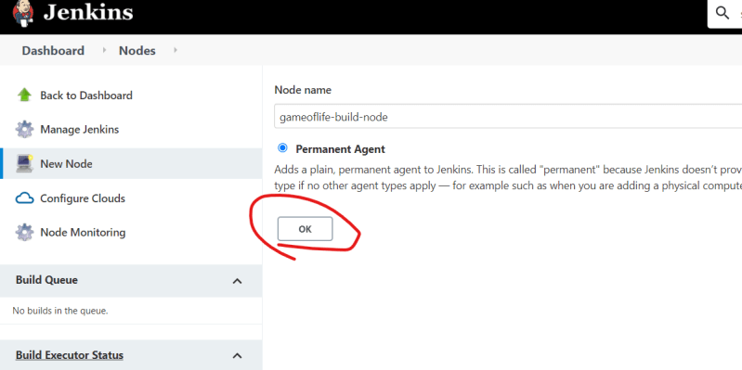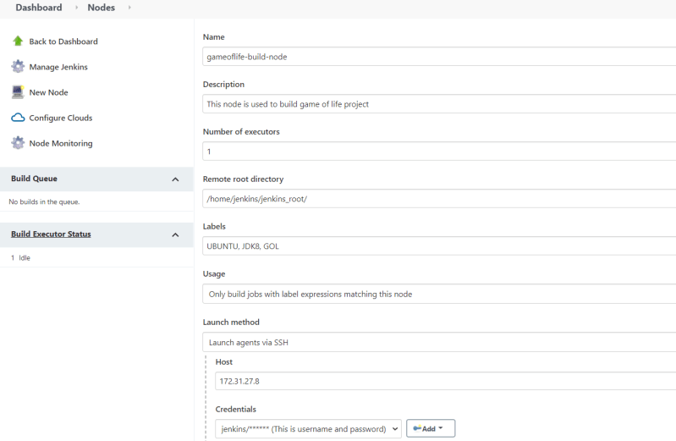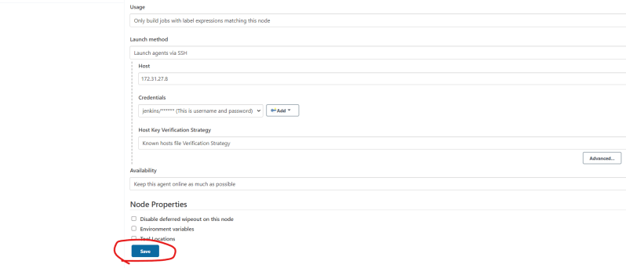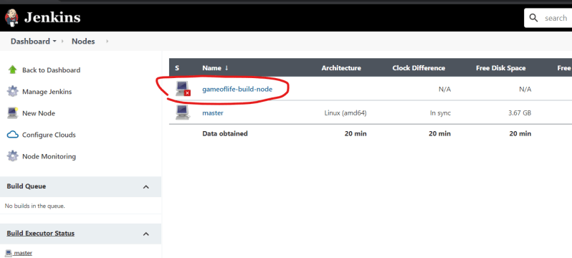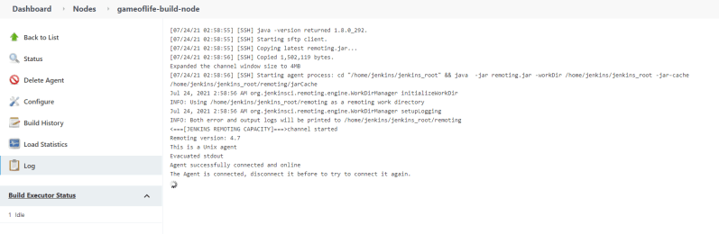
* Now since the node is healthy lets try to build a game of life on the node 